**Shri Sant Gajanan Maharaj College of Engineering, Shegaon**

Department of Electronics and Telecommunication Engineering

ELECTRONICS STUDENTS AND STAFF ASSOCIATION

**ESSA**

**NOTICE**

Date: 03/10/2023

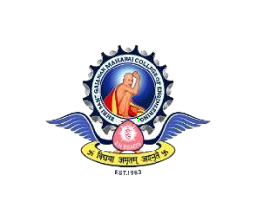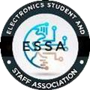

Following students are selected in the executive committee of **ESSA** (Electronics Students And Staff Association) for the academic year 2023-2024.

**Congratulations to all..!!!**

|  |  |
| --- | --- |
| **Team** | **Name** |
| Technical Team | 1.Omika Chaudhary (2U2) 2.Rutuja Gadam (2U2)  3.Saifoddin Shaikh (2U1) |
| Creative Team | 1.Mansi Paraskar (2U2)  2.Sakshi Dhole (2U1)  3.Sakshi Satao (2U2)  4.Shreya Tayade (2U1) |
| Publicity Team | 1.Anurag Fulmali (2U1)  2.Shruti Dabhade (2U2)  3.Vedanshu Bhole (2U2)  4.Neha Bhut (2U2) |
| Program Management Team | 1.Yash Raut (2U1)  2.Tejal Bahirde (2U1)  3.Saloni Magar (2U2) |
| Resource Management  Team | 1. Prerana naphade (2U1) 2. Akshay Pahurkar (2U2) 3. Sakshi Bhojane (2U1) |

|  |  |  |
| --- | --- | --- |
| Prasad Deshmukh | Mrs. K. S. Vyas | Dr. M. N. Tibdewal |
| **Chairperson** | **Faculty Advisor** | **Head of Department** |